Test steering and throttle control

Manual control testing - goal is to establish PID settings, and confirm mode_sw = manual
- Put power supply on to charge the battery
- Use battery BMS to engage power on the charge side using the slide switch
- Get power to the motor
  - Connect wires from steering motor to motor power supply
  - Connect wires from steer angle sensor to appropriate connector
- Put the mode switch on the radio control into the middle position “manual”
- Use battery BMS to engage power on the discharge side using the slide switch; The steering motor should be live now.
- Plug in 12V supply to the USB hub
- Engage master power red handle
- If PID is not established
  - Set all PID settings to zero (0)
  - Move the target steering slightly to the right
  - Slowly increase Kp until the steering motor engages and the wheels move
  - Adjust Kp to find the extremes
  - Reset the map function to be nearer to the extremes to fine tune Kp

cmd_vel control testing – goal is to confirm ability for tractor to steer from cmd_vel statements between -0.73 and 0.73

- Set mode switch to manual
- Confirm you have manual control of the steering
- Set model switch to cmd_vel

The manual way to publish cmd_vel is: $ rostopic pub -r 10 /cmd_vel geometry_msgs/Twist '{linear: {x: 0.3, y: 0.0, z: 0.0}, angular: {x: 0.0,y: 0.0,z: 0.0}}'

rostopic pub -r 10 /cmd_vel geometry_msgs/Twist '{linear: {x: 0.0, y: 0.0, z: 0.0}, angular: {x: 0.0,y: 0.0,z: 0.5}}'

Input into file: testing_cmd_vel_pub_input.txt
0.0, 0.0, 5
0.0, 0.25, 5
0.0, 0.5, 5
0.0, 0.0, 5
0.0, -0.25, 5
0.0, -0.5, 5
- $ cd /home/tractor/ros1_lawn_tractor_ws/project_notes/code_for_testing
- $ python3 testing_cmd_vel_pub.py

- Test transmission, while disengaged, no motor running
  - Manual control - mark the position of the control lever in order to check against cmd_vel statements
  - Issue rostopic pub cmd_vel for forward (1.8), reverse (-1), neutral (0)
- Motor running - on blocks
  - Manual control
    - What value starts to move wheels forward
    - What value starts to move the wheels backward
    - Does that match "73" as neutral?
- Motor Running - In the yard
  - Manual control - Use wheel odom data and the GPS data
  - Adjust the transmissionFullForwardPos until speed achieves 1.8 m/s
  - Adjust transmissionFullReversePos until -1.0 m/s is achieved when full reverse
- Cmd_vel control
  - Simple one position
  - Simple 3 positions - straight line

OLD NOTES
Assumptions
- Motor is mounted, but not powered
- Angle sensor is mounted, connected to the Teensy which is connected to the RPi and basic testing has been conducted
- The sensor value for hard right and hard left is known

To be completed in this step:
- 3D print the holder for the motor controller and Teensy
- Connect 12V power to the motor controller from battery
- Connect the motor controller (GND, Direction and PWR level) to the Teensy
- Fasten the motor controller and Teensy to the motor mount

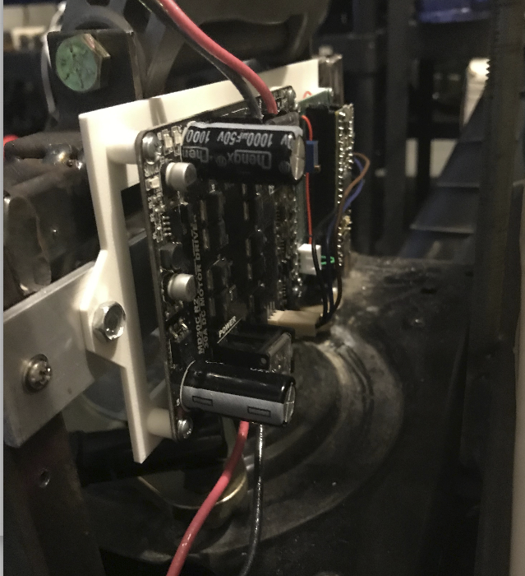 | 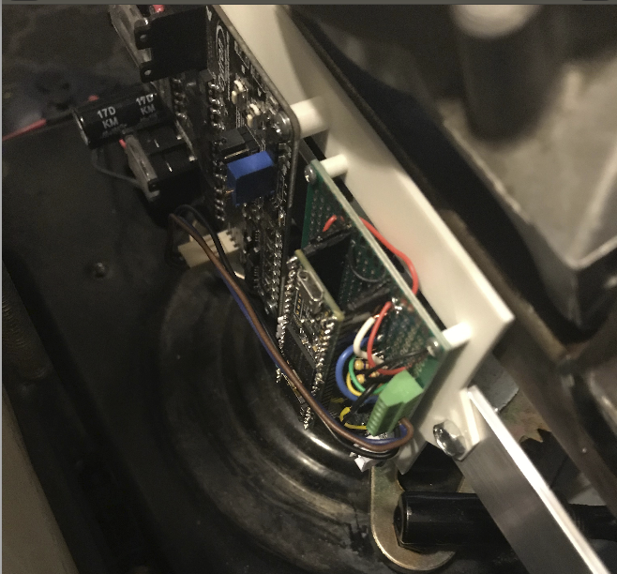

- Connect the motor controller power leads to the motor
- Run sample program that reads steering sensor
  - Connect USB drive
    - Make cable long enough to connect
    - Route cable
    - See which devices are currently connected $ ls /dev/ttyACM*
      - /dev/ttyACM0 /dev/ttyACM1 /dev/ttyACM2 /dev/ttyACM3
  - Create a UDEV rule for the front_angle Teensy

- Create a UDEV rule for the front_angle Teensy
  - Background: https://arduino.stackexchange.com/questions/3680/in-linux-how-to-identify-multiple-arduinos-connected-over-usb; http://www.googlinux.com/clearing-dmesg-logs/index.html
  - Logon to the RPI; Confirm the teensy is able to be seen by RPi. $ ls /dev/ttyACM*, then connect front angle sensor, $ ls /dev/ttyACM*
  - Unplug / turn off power to any USB devices
  - Save the dmesg log. $ dmesg > dmesg-`date +%d%m%Y`.log
  - Clear the log. $ sudo dmesg -c
  - Plug in the Teensy to be used. Remember this has a unique serial number.
  - List the dmesg $ dmesg
  - Results:
ubuntu@ubiquityrobot:~$ dmesg
[118616.881363] usb 1-1.3.2: new full-speed USB device number 45 using dwc_otg
[118617.014192] usb 1-1.3.2: New USB device found, idVendor=16c0, idProduct=0483
[118617.014207] usb 1-1.3.2: New USB device strings: Mfr=1, Product=2, SerialNumber=3
[118617.014215] usb 1-1.3.2: Product: USB Serial
[118617.014223] usb 1-1.3.2: Manufacturer: Teensyduino
[118617.014230] usb 1-1.3.2: SerialNumber: 5588760
[118617.015401] cdc_acm 1-1.3.2:1.0: ttyACM0: USB ACM device

- Setup udev rule mapped to “steer_motor ” because later you will want to update the setting: “upload port = /dev/steer_motor ” in the platformio.ini file. Background reading: https://linuxconfig.org/tutorial-on-how-to-write-basic-udev-rules-in-linux
- Edit and update this line, then copy it because it will be easier to paste into the editor.
- SUBSYSTEM=="tty", ATTRS{idVendor}=="16c0" , ATTRS{idProduct}=="0483" , ATTRS{serial}=="5588760", SYMLINK+="steer_motor"
- Change permissions so I can use FileZilla and Sublime to edit the udev files
  - $ sudo chmod -R 777 /etc/udev/rules.d/05-serial.rules
- $ sudo edit /etc/udev/rules.d/05-serial.rules
- 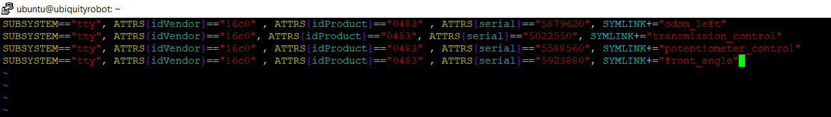
- Move the cursor to the end of the last character in the last line
- Press INSERT; Move the cursor to the end and press enter
- Copy the new line above and paste into the editor by right mouse clicking at the beginning of the new line.
- Press Escape to exit the insert mode
- Save the file by entering “:w” then enter
- Quit using “:q” then enter
- Reboot the RPi for the changes to take effect $ sudo reboot
- $ ls /dev/steer_motor to confirm the link has been made
- 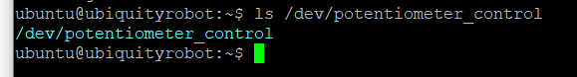
- Update PlatformIO environment ini
- Open FileZilla, Update the platformio.ini file in /home/ubuntu; Add section for front_angle
;
[env:front_angle]
platform = teensy
board = teensy31
framework = arduino
upload_port = /dev/front_angle
- “board = teensy35” is used for a Teensy 3.5
- Update bash scripts to help PlatformIO compiling
  - Background: There are two bash scripts that have been used for compiling, compile_a.sh and compile_b.sh. These scripts need to be updated because you have a new microcontroller connected to the USB hub.
  - Connect all the USB cables and run $ grep 16c0 /sys/bus/usb/devices/*/idVendor to list all the Teensy devices connected.
  - For testing, run the scripts without the platformio or roslaunch commands enabled. I had issues getting permissions correct.
  - If you reboot, to resolve permission issues run:
    - $ sudo chown root:plugdev /sys/bus/usb/drivers/usb/{bind,unbind}
    - $ sudo chmod g+w /sys/bus/usb/drivers/usb/{bind,unbind}
    - See: https://community.platformio.org/t/multiple-boards-upload-port-works-but-crashes-2nd-board/9029/8

ubuntu@ubiquityrobot:~$ grep 16c0 /sys/bus/usb/devices/*/idVendor
/sys/bus/usb/devices/1-1.3.1.1/idVendor:16c0 (joystick)
/sys/bus/usb/devices/1-1.3.1.2/idVendor:16c0 (left speed)
/sys/bus/usb/devices/1-1.3.1.3/idVendor:16c0 (transmission)
/sys/bus/usb/devices/1-1.3.1.4/idVendor:16c0 (front_angle)
/sys/bus/usb/devices/1-1.3.2/idVendor:16c0 (steer_motor)

(NOTE: Put the latest device IDs in the file “Documenting the Teensy device ID’s”)

File: compile_a.sh
#!/bin/bash
# this script to "turn off" the USB ports and to start the compile process
#
# Comment out the device you will be programming
#
# (1 of 2) Comment OUT the device you WILL be programming or devices not connected
#
#echo -n "1-1.3.1.1" > /sys/bus/usb/drivers/usb/unbind # diy joystick
echo -n "1-1.3.1.2" > /sys/bus/usb/drivers/usb/unbind # left speed
echo -n "1-1.3.1.3" > /sys/bus/usb/drivers/usb/unbind # transmission
echo -n "1-1.3.1.4" > /sys/bus/usb/drivers/usb/unbind # front_angle
#echo -n "1-1.3.2" > /sys/bus/usb/drivers/usb/unbind # steer_motor
#
# (2 of 2) UN-COMMENT the line for the platformio environment you WANT TO COMPILE
#
# Platformio environments include: [env:joystick], [env:left_speed], [env:transmission], [env:front_angle], [env:steer_motor]
#sudo platformio run -t upload -e front_angle # for [env:front_angle]
sudo platformio run -t upload -e steer_motor # for [env:steer_motor]
#sudo platformio run -t upload -e transmission # for [env:transmission]

File: compile_b.sh
#!/bin/bash
# this script to "turn on" the USB ports after the compile process is complete
#
# Comment OUT the board that IS being programmed. It will not need the "bind" statement. All other connected devices should be active.
#
#echo -n "1-1.3.1.1" > /sys/bus/usb/drivers/usb/bind # joystick
echo -n "1-1.3.1.2" > /sys/bus/usb/drivers/usb/bind # left speed
echo -n "1-1.3.1.3" > /sys/bus/usb/drivers/usb/bind # transmission
echo -n "1-1.3.1.4" > /sys/bus/usb/drivers/usb/bind # front_angle
#echo -n "1-1.3.2" > /sys/bus/usb/drivers/usb/bind # steer_motor
#

# start the launch file that will initiate the Teensy's you want to test
cd /home/ubuntu/catkin_ws/src
roslaunch teensy_launch.launch
#roslaunch steer_test_launch.launch
#roslaunch transmission_test_launch.launch

To test:
- $ grep 16c0 /sys/bus/usb/devices/*/idVendor
- $ ls /dev/ttyACM*
- If you have code to compile and multiple Teensy’s are connected and active, run $ bash compile_a.sh then $ ls /dev/ttyACM*
- Alternatively if the USB ports are still unbound (i.e. only one Teensy active), run $ sudo platformio run -t upload -e steer_motor
- Once compile is clean and you want to test, run $ bash compile_b.sh then $ ls /dev/ttyACM*
- If you have seen how they appear, disappear and reappear, you can now take out the comment for the PlatformIO statement in compile_a.sh
  - If USB ports are still unbound, run $ sudo platformio run -t upload -e steer_motor
- Test compiling and running blink.cpp
- Update launch file - steer_test_launch.launch to only launch the angle and motor controller teensy.

steer_test_launch.launch
<launch>
<?ignore - used to comment out lines
<node ns="transmission_teensy" name="transmission_cntrl" pkg="rosserial_python" type="serial_node.py" args="/dev/transmission_control" output="screen" />
<node ns="potentiometer_teensy" name="potentiometer_output" pkg="rosserial_python" type="serial_node.py" args="/dev/potentiometer_control" output="screen" />
<node ns="left_speed_teensy" name="left_speed" pkg="rosserial_python" type="serial_node.py" args="/dev/odom_left" output="screen" />
?>
<node ns="front_angle_teensy" name="front_angle" pkg="rosserial_python" type="serial_node.py" args="/dev/front_angle" output="screen" />
<node ns="steer_motor_teensy" name="steer_motor" pkg="rosserial_python" type="serial_node.py" args="/dev/steer_motor" output="screen" />
</launch>

- Test program
  - Once you have a complete compile and before launching the programs
    - Check power to motor
    - Ensure the work area is clear; Double check the steering rods and there are no obstacles (e.g. wires) in the way
    - Remind yourself where to disconnect power should you need to do so
    - On RPi,
      - $ ls /dev # you should only see one teensy (i.e. steer_motor)
      - Run $ bash compile_b.sh
      - Optionally if the bind statements have already been run:
        - $ cd /home/ubuntu/catkin_ws/src
        - $ roslaunch steer_test_launch.launch
  - On Laptop
    - Ctrl+Alt+T, $ rqt
    - Organize rqt screens to monitor steering PWM, cmd_vel/angular/x and front_angle_klm/data. Use “dock” icon to move screens to desired position
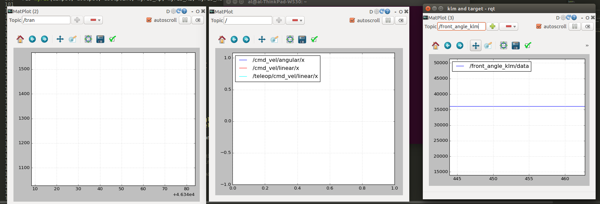
    - Connecting the joystick - See Step 4 - Install ROS-Ag lawn tractor simulator section Test drive using gamepad for background and to confirm port identifier.
    - Start joy_input to transfer data to cmd_vel:
- Ctrl+Alt+T, $ roslaunch tractor_teleop cmd_vel_mux.launch
- Ctrl+Alt+T, $ roslaunch tractor_teleop drive_teleop.launch joy_dev:=/dev/input/js0
- Note: drive_teleop.launch has as a default: <arg name="joy_dev" default="/dev/input/js0"/> If your joystick is on js1 you can either change the launch file or adjust the argument.
- Alternatively, the command below has both of the above commands combined
  - $ roslaunch tractor_teleop drive.launch
    - At this point you should be able to press the deadman switch, move the steering joystick and see the target angular.z adjust.

Next Step
Confirm steer straight and left right settings.

- Choose Plugins -> Robot Tools -> Robot Steering

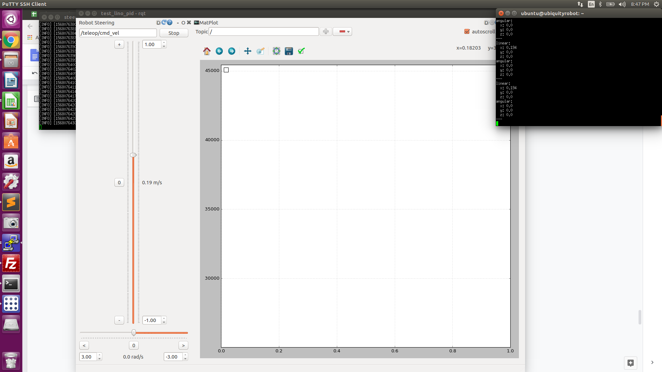

In the rqt topic put /teleop/cmd_vel in the topic field
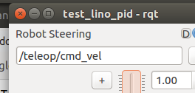
On the RPi echo the topic and move the slider in rqt to see the topic being published

- Drag the window all the way to the right
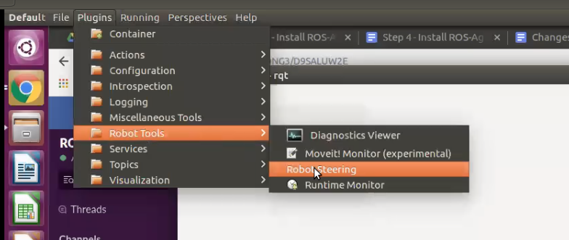
- You can now adjust the slide bars and send cmd_vel command using this interface
- An alternative is to run a bash script written for this purpose.
#!/bin/bash
timeout 10 rostopic pub -r 10 teleop/cmd_vel geometry_msgs/Twist '{linear: {x: 0.0, y: 0.0, z: 0.0}, angular: {x: 0.0,y: 0.0,z: 0.5}}'
timeout 10 rostopic pub -r 10 teleop/cmd_vel geometry_msgs/Twist '{linear: {x: 0.0, y: 0.0, z: 0.0}, angular: {x: 0.0,y: 0.0,z: 0.0}}'
timeout 10 rostopic pub -r 10 teleop/cmd_vel geometry_msgs/Twist '{linear: {x: 0.0, y: 0.0, z: 0.0}, angular: {x: 0.0,y: 0.0,z: 0.5}}'

- Plugins -> Visualizations -> Plot will allow you to subscribe and visualize (i.e. plot) rostopics
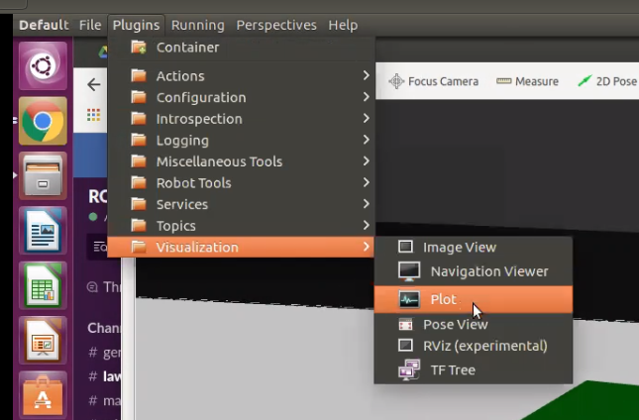
- Plugins -> Topics -> Topic Monitor lets you drag and drop the topics you are interested in

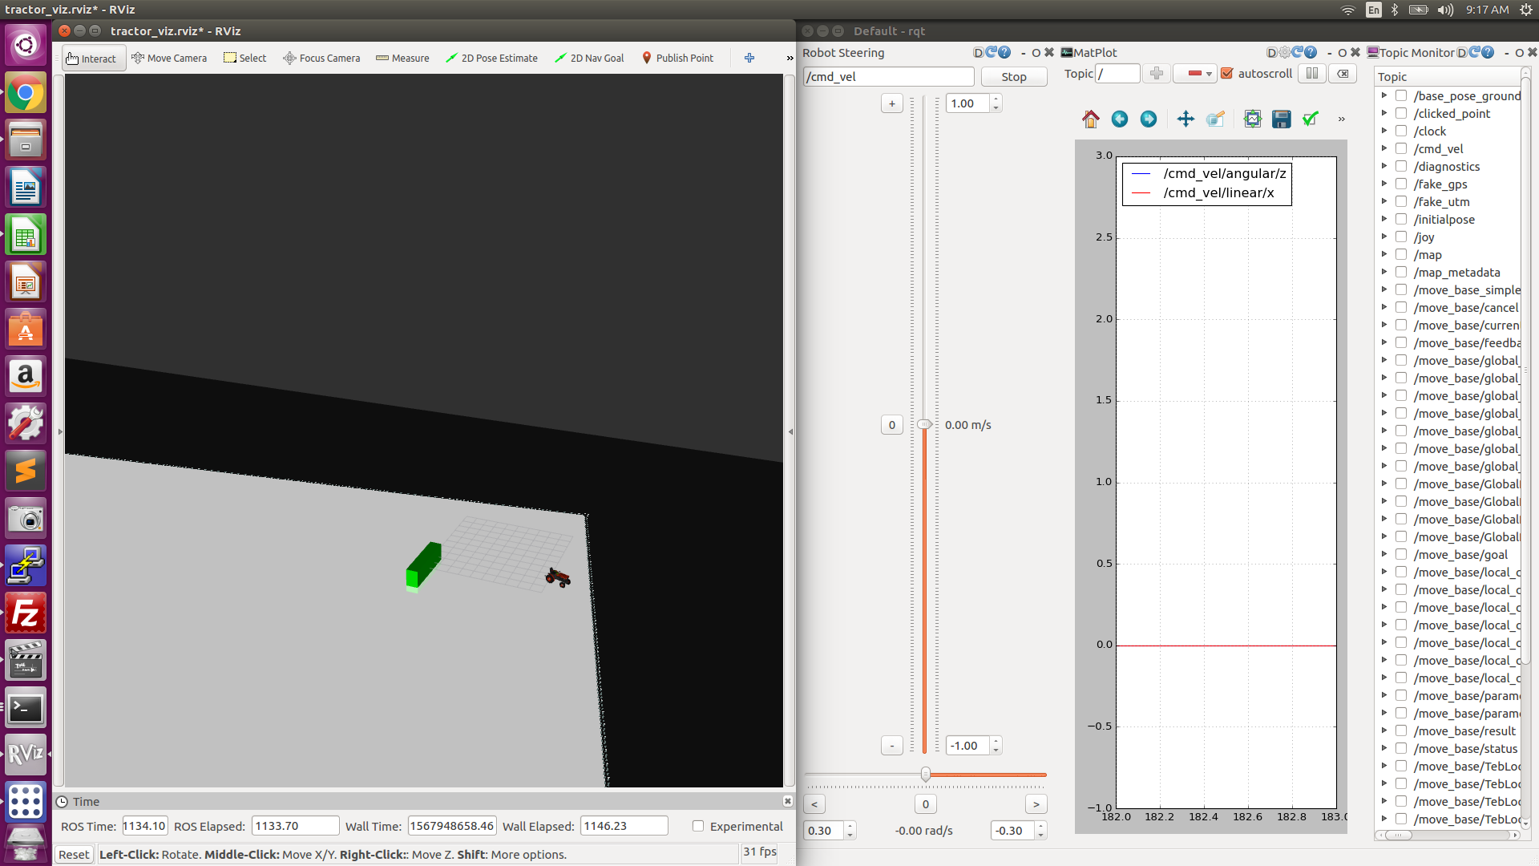

Testing protocol

Cmv_vel angular.z | Points to look for
0.0 | Is the steering steady and straight; Is the steer effort zero
0.03 to -0.03 | Does the steering react and move to these smaller increments
Move from 0 to +/- .5 | Does the steering reach the target and steer effort go to zero? What there overshoot? How long did it take to achieve the target?
1 and -1 | Does the steering reach the target and steer effort go to zero? What there overshoot? How long did it take to achieve the target?

Example output going from: 0.0 -> -0.5 -> +0.5 -> -0.7 -> +0.7 -> 0.0

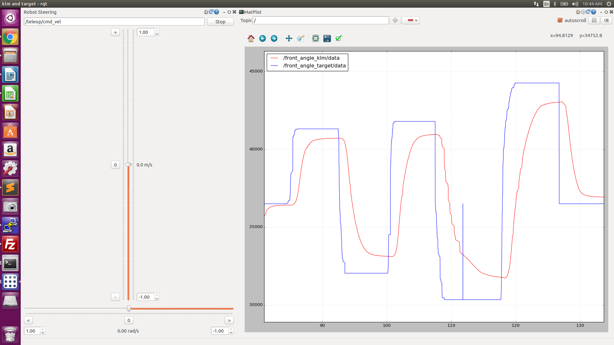

$ timeout 3 rostopic pub -r 10 /cmd_vel geometry_msgs/Twist '{linear: {x: 0.0, y: 0.0, z: 0.0}, angular: {x: 0.0,y: 0.0,z: 0.5}}'
$ timeout 3 rostopic pub -r 10 /cmd_vel geometry_msgs/Twist '{linear: {x: 0.75, y: 100.0, z: 0.0}, angular: {x: 200.0,y: 0.0,z: 0.0}}'

10/15/19
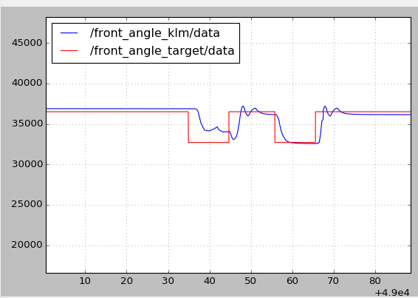
Using rosparam to change settings
The command <rosparam param="steering">[28900.1, 46300.0, 36500.0, 50.0, 2.0]</rosparam> is located in the teensy_launch.launch and steer_test.launch files. This sets the steering parameters:
steer_left_max = 28900;
steer_right_max = 46300;
steer_straight = 36500;
max_steer_eff = 50;
steer_Ki = 2;

The command that will also do the same thing is $ rosparam set /steering "[28900.0, 46300.0, 36500.0, 50.0, 2.0]"

I adjusted the steer straight to be 36800
10/18/19
- $ rosparam set /steering "[28900.0, 46300.0, 38000.0, 70.0, 2.0]"

Once you have the transmission running you can further tune the settings. For example, in the grass, get the steer_effort adjusted

3/1/20
Import KLM perspectives in rqt
Dragging from right to left with the right mouse button down will slow down the speed of the plot.
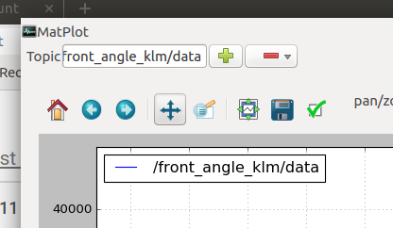Press the up/down arrow pan axis first
Doing the same up and down to zoom in on the preferred range.

Straight ahead  position_klm: 36102 | 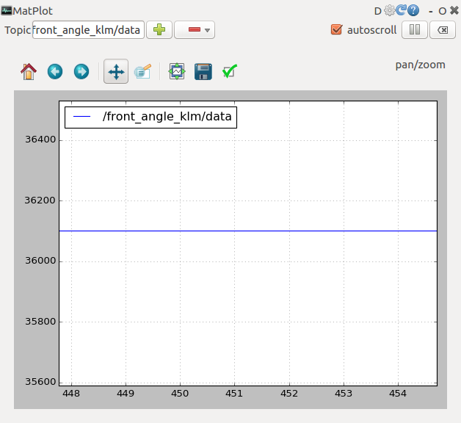 | 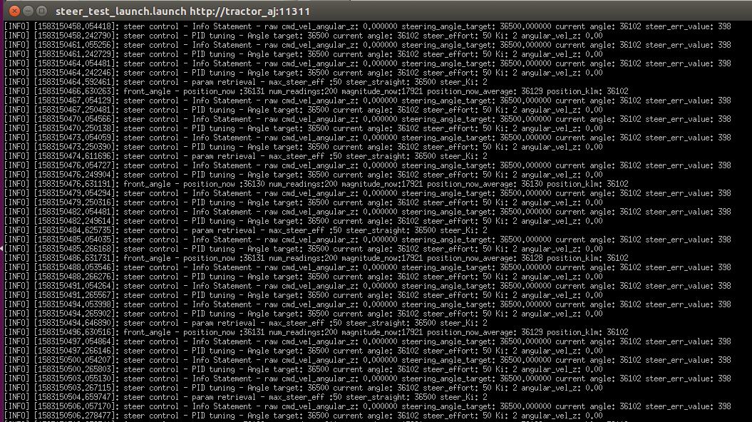
Full left
position_klm: 27184
Full right
position_klm: 47415

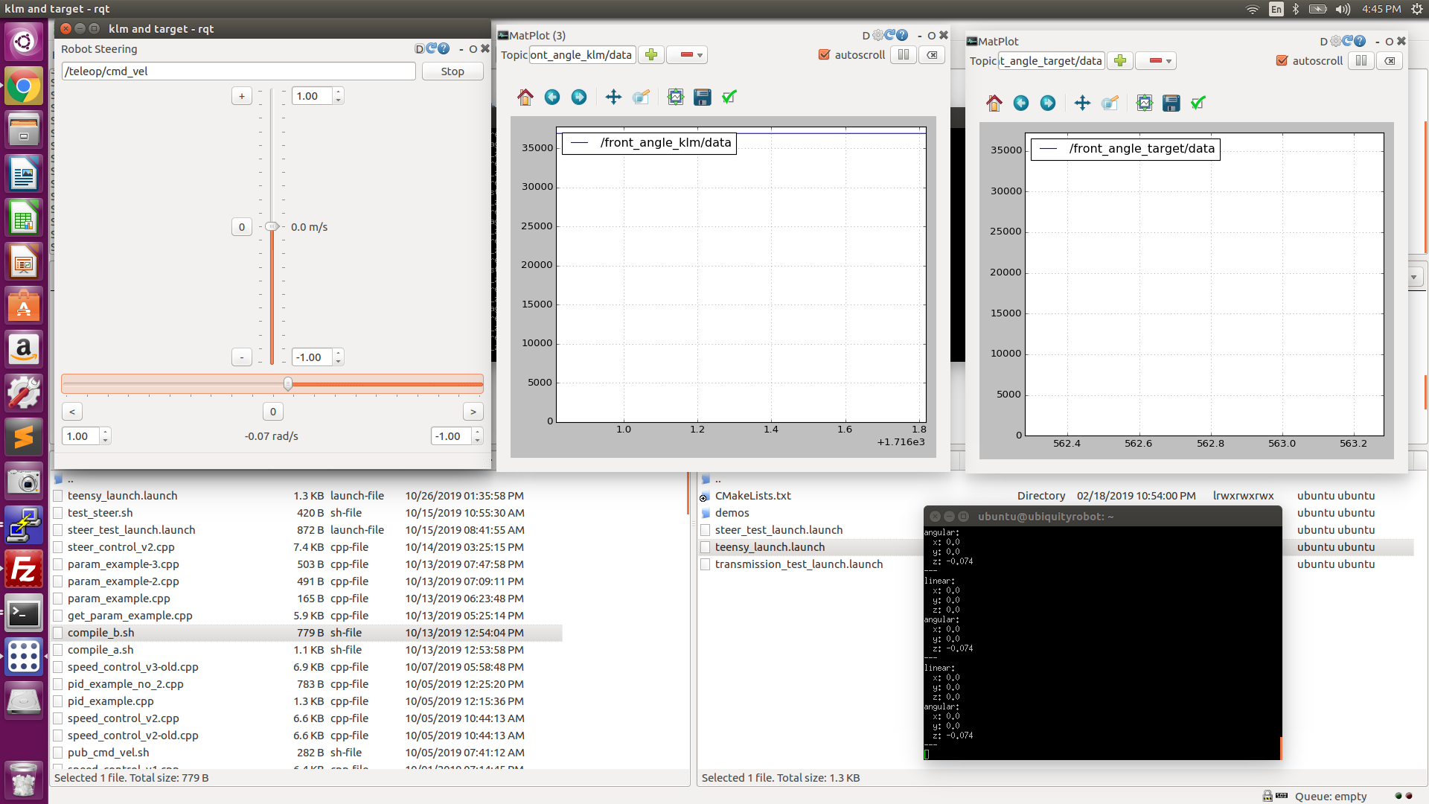
The steering is not making the full rotation; Check variables being passed.

5/17/20
$ timeout 3 rostopic pub -r 10 /cmd_vel geometry_msgs/Twist '{linear: {x: 0.0, y: 0.0, z: 0.0}, angular: {x: 0.0,y: 0.0,z: 0.5}}'
No movement at all - This issue was the signal wire to the motor controller had come loose.
$ rosparam set /steering “[27900.0, 45798.0, 36874.0, 60.0, 3.0]”

- $ rosparam set /steering "[27900.0, 45798.0, 36874.0, 60.0, 3.0]"
- $ rosparam set /steering "[23600.0, 44300.0, 33319.0, 60.0, 3.0]"
<rosparam param="steering">[24300.0, 44000.0, 34000.0, 70.0, 3.0]</rosparam>

5/18/20
The wheels banged into a big ant mound and turned the wheels hard one direction. I need to re-confirm left, right, center.

Current:$ rosparam get /steering
[24300.0, 44000.0, 34000.0, 70.0, 3.0]

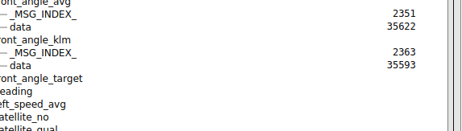
Left
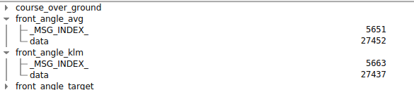

Right
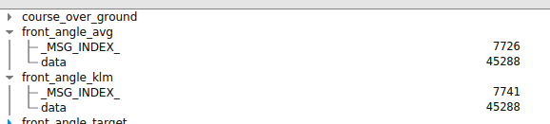

- $ rosparam set /steering "[27400.0, 45200.0, 35600.0, 70.0, 3.0]"

0.5, -0.3, 60 - produces a circle about 15’ in diameter
0.5, -0.2, 60 - produces a circle about 17’ in diameter

Positive still produced a right hand turn!

0.5, 0.005, 60
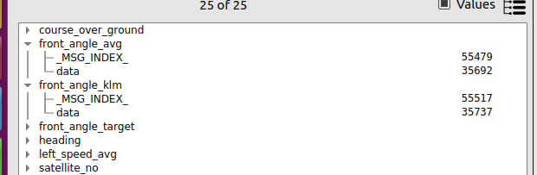

After 30 minutes of testing the center seems to be off which is leading to the inability to turn left.

I need to recenter.: 29209

Full left: 19200
Full right: 42000
42022

- $ rosparam set /steering "[19200.0, 42000.0, 29209.0, 70.0, 3.0]"

Pulling left when going straight

- rosparam set /steering "[19200.0, 42000.0, 30000.0, 70.0, 3.0]"
- rosparam set /steering "[19200.0, 42000.0, 30400.0, 70.0, 3.0]"

Center has become unadjusted again. It is near 40000!

Just to get the tractor back
- rosparam set /steering "[38200.0, 46000.0, 42000.0, 70.0, 3.0]"

5/22/20
2 rotation potentiometer keeping track of the rotations

Continuous rotation potentiometer
https://www.usdigital.com/products/encoders/absolute/magnetic/MA3

